1-10

Equivalence Partitioning - testar valores entre os limites

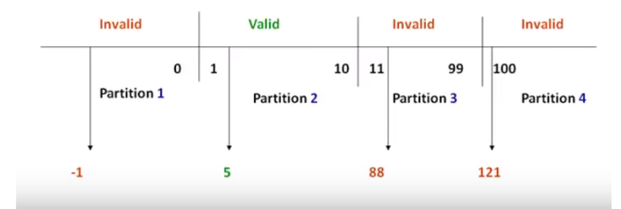

Testamos o -1, 5, 88, 121

Boundary Value Analysis - testar o range (limites)

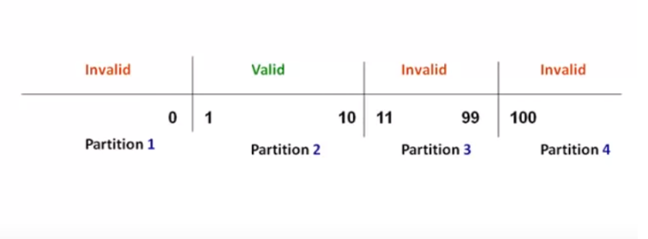

We need test: extreme edges: 0,**1,10**,11,99,100

below the extreme edges: 0,9

above the extreme edges:2,11